Kyle Gilpin

May 18, 2021

IT FDN 110 A

Assignment 06

<https://github.com/Tekpro007/IntroToProg-Python-Mod06.git>

Creating a To Do List

# Introduction

In this assignment, I will be adding onto an existing template file to finish the script. I will be writing the missing functions for importing data from the user and display the data from a text file stored on the hard drive.

# Creating the PyCharm Project file

Before starting my script, I created a new project in PyCharm and named it assignment 06. To create the project, I opened PyCharm and selected New Project under the File Menu. I chose the location to be C:\_PythonClass\Assignment6 and unselected the creation of the main.py welcome script as seen in figure 1.

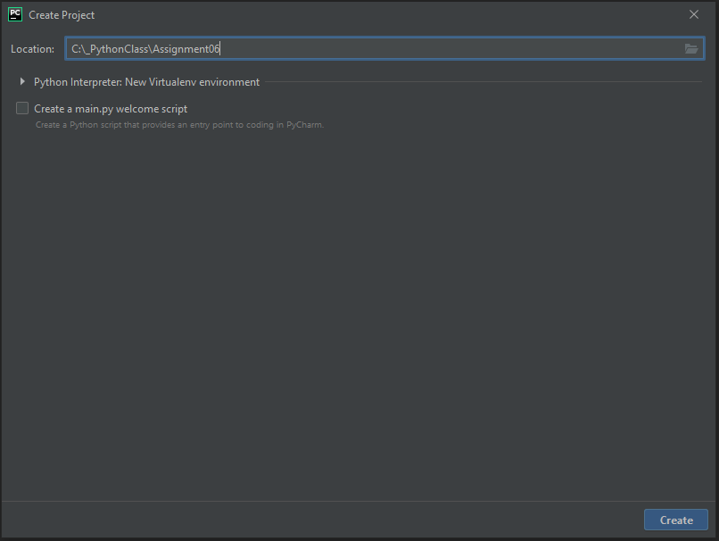

Figure (Creating Project in PyCharm)

I moved the Python script Assigment06_Starter.py from the class module into the assignment06 folder. I then navigated from File->Open in PyCharm to the script Assigment06_Starter.py and clicked ok as see in figure 2.

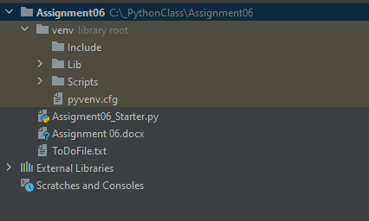

Figure Importing starter Python file

# Finishing the Assigment06_Starter.py

To begin with, I looked over the code that was existing and ran the code. I started with the first choice by building the function for processing new tasks. I built the code to pass in the variables. The function for adding data to a list is shown below as seen in figure 3

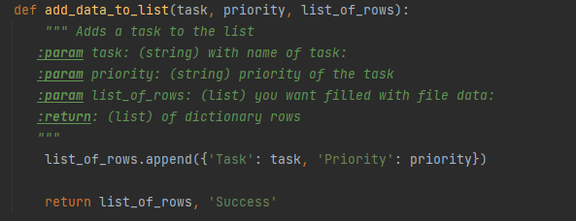

Figure Function for adding data

I then proceeded to build the function for inputs. I used my knowledge from prior lessons to create the input function as seen in figure 4.

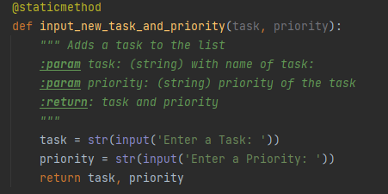

Figure Add data from input function

To finish option for inputting data, I called both the input IO function and the processing function as seen below in figure 5.

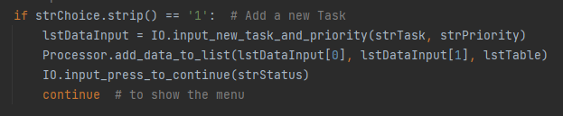

Figure 5 Adding new task.

I then proceeded to build the function for removing tasks. I used the examples from the lectures to create the code that would remove the data based on a matching input from the user. This is seen in figure 6.

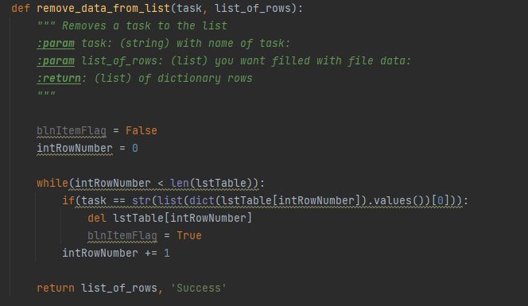

Figure 6 Function for removing data.

Following the same process for adding tasks, I created the IO function for removing them as seen in figure 7.

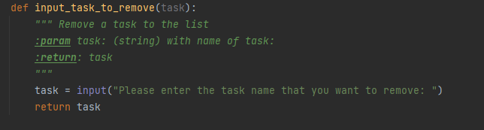

Figure 7 IO function for removing input

I then called both function when option 2 was chosen. This code is seen in figure 8.

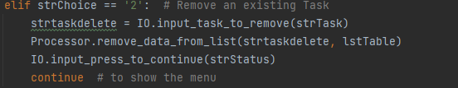

Figure 8 Removing tasks

My next step was to create a function for saving data. This is seen in the below figure 9.

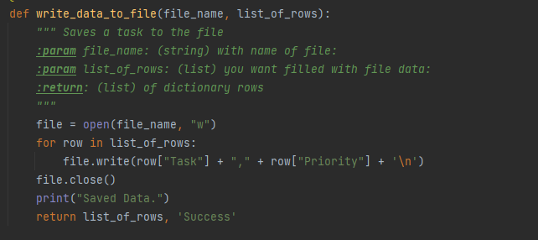

Figure 9 Function for writing data

This is my script fully running in PyCharm as seen in figure 10

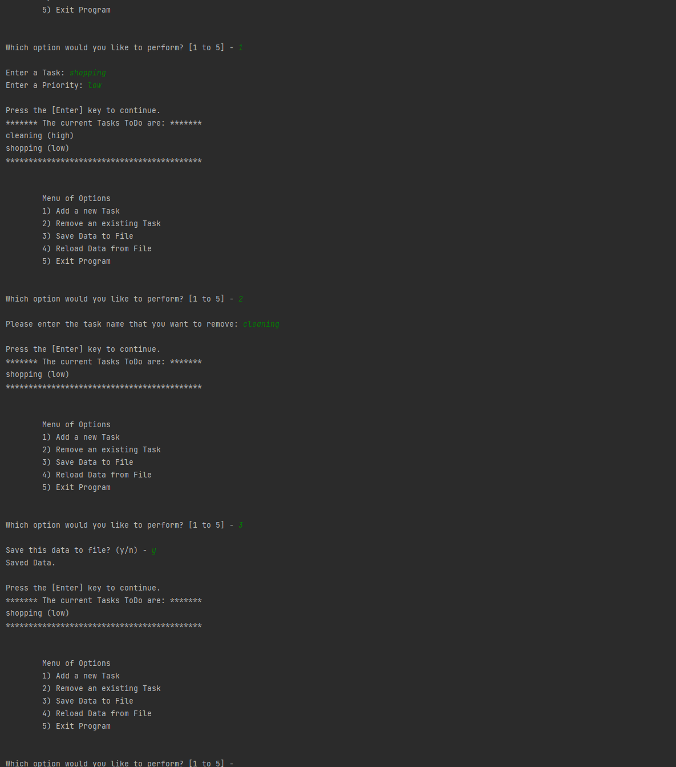

Figure 10 Running in PyCharm

This is a screenshot from an OS command shell as seen in figure 11.

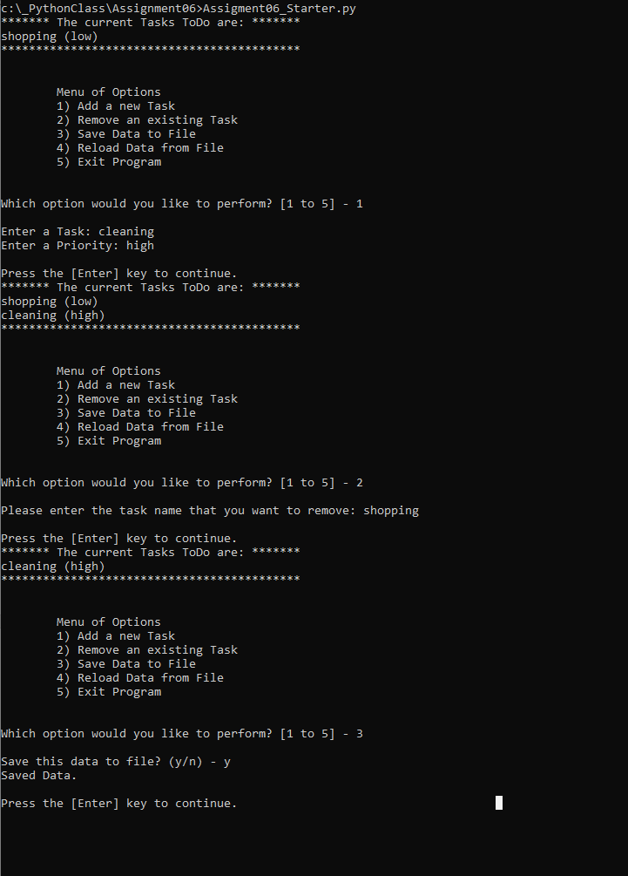

Figure 11 Running from OS Shell

# Summary

As part of this assignment, I learned to work with a template script that had some of the data already created. I found it to be helpful in some areas and more difficult in others. This demonstrates the need to document and code in logical manner to allow for other developers to easily understand the code. I learned specifically how to create functions and pass variables from one function to the next.